**SQL Exercise 4**

1. **Display the minimum Status in the Supplier table.**

mysql> select min(status)

-> from supplier;

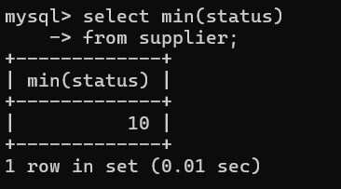

1. **Display the maximum Weight in the Parts table.**

mysql> select min(weight)

-> from parts;

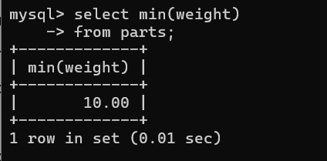

1. **Display the average Weight of the Parts.**

mysql> select avg(weight)

-> from parts;

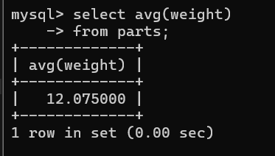

1. **Display the total Quantity sold for part ‘P1’.**

mysql> select sum(qty)

-> from spj

-> where `p#` = 'p1';

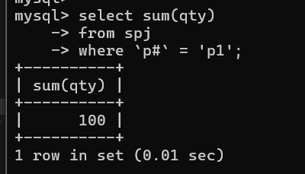

**5. Display the total Quantity sold for each part..**

mysql> select `p#` , sum(qty)

-> from spj

-> group by `p#`;

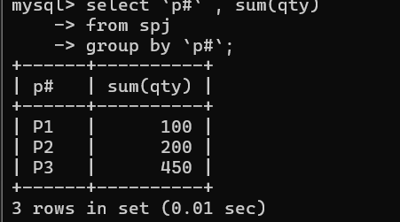

**6. Display the average Quantity sold for each part.**

mysql> select `p#`,avg(qty)

-> from spj

-> group by `p#`;

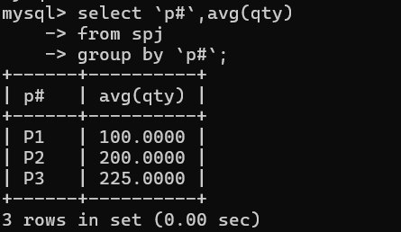

**7.Display the maximum Quantity sold for each part, provided the maximum Quantity is greater than 100.**

mysql> select `p#`, max(qty)

-> from spj

-> group by `p#`

-> having max(qty)> 100;

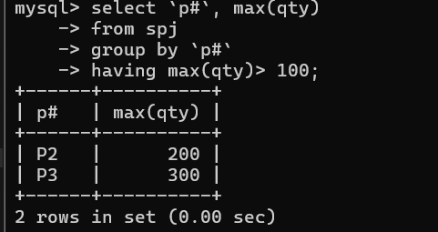

**8.Display the Status and the count of Suppliers with that Status.**

mysql> select status, count(*)

-> from supplier

-> group by status;

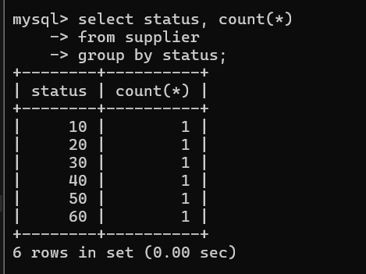

**9.Display the count of Projects going on in different cities.**

mysql> select city , count(*)

-> from projects

-> group by city;

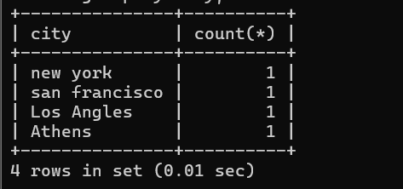

**10.What is the difference between COUNT(Status) and COUNT(*) ?**

Count (status): This function counts only the rows where the Status column has non-NULL values. If there are any rows where Status is NULL, those rows will not be included in the count.

COUNT(*): This function counts all rows in the result set, regardless of whether they contain NULL values in any column. It includes every row.

**11. Display the Status and the Count of Suppliers with that Status in the following format as shown below:-**

**Status Count**

**Ten 1**

**Twenty 2**

**Thirty 3**

mysql> select case

-> when status = 10 then 'ten'

-> when status = 20 then 'twenty'

-> when status = 30 then 'thirty'

-> else 'other'

-> end as status,

-> count(*) from supplier

-> group by status

-> order by status;

